Hands-on Model Calibration in R

Model Calibration Exercise

|  |  |
| --- | --- |
|  |  |
| Fernando Alarid-Escudero, PhD1  Eva A. Enns, MS, PhD2  M.G. Myriam Hunink, MD, PhD3,4,  Hawre J. Jalal, MD, PhD5  Eline M. Krijkamp, MSc3  Petros Pechlivanoglou, PhD6 |  |

Acknowledgements and attribution

Citations:

1. Jalal H, Pechlivanoglou P, Krijkamp E, Alarid-Escudero F, Enns E, Hunink MG. An Overview of R in Health Decision Sciences. Med Decis Making. 2017; 37(3): 735-746.

https://journals.sagepub.com/doi/abs/10.1177/0272989X16686559

1. Krijkamp EM, Alarid-Escudero F, Enns EA, Jalal HJ, Hunink MGM, Pechlivanoglou P. Microsimulation modeling for health decision sciences using R: a tutorial. *Med Decis Making*. 2018; 38(3): 400-422. https://journals.sagepub.com/doi/abs/10.1177/0272989X18754513
2. Alarid-Escudero F, MacLehose RF, Peralta Y, Kuntz KM, Enns EA. Nonidentifiability in Model Calibration and Implications for Medical Decision Making. Med Decis Mak 2018;38:810–21. https://journals.sagepub.com/doi/abs/10.1177/0272989X18792283

In collaboration of:

1 Center for Research and Teaching in Economics (CIDE), Aguascalientes, Mexico

2 University of Minnesota School of Public Health, Minneapolis, MN, USA

3 Erasmus MC, Rotterdam, The Netherlands

4 Harvard T.H. Chan School of Public Health, Boston, USA

5 University of Pittsburgh Graduate School of Public Health, Pittsburgh, PA, USA

6 The Hospital for Sick Children, Toronto and University of Toronto, Toronto ON, Canada



**© Copyright 2017, THE HOSPITAL FOR SICK CHILDREN AND THE COLLABORATING INSTITUTIONS. All rights reserved in Canada, the United States and worldwide. Copyright, trademarks, trade names and any and all associated intellectual property are exclusively owned by THE HOSPITAL FOR SICK CHILDREN and the collaborating institutions and may be used, reproduced, modified, distributed or adapted with appropriate attribution.**

### Exercise: Calibration of a Sick-Sicker Model

In this exercise, we will calibrate a model of a hypothetical Sick-Sicker disease. A Markov model of the Sick-Sicker disease has been implemented using four health states: Healthy (H); two disease states, Sick (S1) and Sicker (S2); and Dead (D). A state transition diagram is shown in Figure 1. All individuals start in the Healthy state (H). Over time, healthy individuals may develop the disease and can progress to S1. Individuals in S1 can recover (return to state H), progress further to S2 or die. Once in S2, individuals cannot recover (i.e. cannot transition back to either S1 or H). Individuals in H have a baseline probability of death, while individuals in S1 and S2 have an increased mortality rate compared to healthy individuals, modeled as a hazard ratio applied to the baseline mortality rate.

Unfortunately, while we can identify those who are afflicted with the illness through obvious symptoms, we can’t easily distinguish those in the S1 state from the those in the S2 state. Thus, we can’t directly estimate state-specific mortality hazard ratios, nor do we know the transition probability of progressing from S1 to S2. We do have some idea of the plausible ranges for these unknown parameters; these ranges are listed in Table 1. All other model parameters are known and are also listed in Table 1.

There are three calibration targets to be used in this example: (1) observed survival of a cohort over time; (2) disease prevalence in a cohort over time; and (3) among sick patients (S1+S2), the proportion who are in the S1 state at three points in time. The first two targets came from an observational study of a typical cohort of individuals. The third target was obtained by subjecting ill patients to an invasive procedure which can determine disease stage but can’t be used routinely due to its invasiveness. The calibration target values are provided in the data file “SickSicker_CalibTargets.RData”, which contains a list with three data frames: Surv, Prev, and PropSick.

## Tasks

1. Use the R script “SickSicker_CalibTemplate.R” as a starting point to code the calibration of the Sick-Sicker.
   * Load and plot the calibration target data stored in “SickSicker_CalibTargets.RData”.
   * Source the file, “SickSicker_MarkovModel_Function.R”, which contains the Sick-Sicker model function, run_sick_sicker_markov(). This function takes in a vector of three parameters, c(p_S1S2, hr_S1, hr_S2), and returns model outputs corresponding to the calibration targets. Try using the model function and look at the output.
2. Implement the calibration of the Sick-Sicker model using random search with 1000 random samples. Copy code from the calibration of the 3-state model, modifying where necessary. Remember that the Sick-Sicker model needs to be calibrated to three different targets (instead of one) by varying three different inputs (instead of two).
   * Explore the top-fitting input sets (e.g. top 10, top 100). To visualize the best-fitting sets, use pairs.panels() and scatterplot3d() functions. Type “?scatterplot3d” for function documentation.
   * Plot the model-predicted output at the best-fitting parameter set overlaid over each of the three types of calibration targets (extend the plotting code in the 3-state model calibration script).
3. Save a new copy of your Sick-Sicker model calibration code. Change the implementation from random search to Nelder-Mead, using 100 random starting points. Where do you need to make changes? Use the Nelder-Mead calibration of the 3-state model as a guide.
   * Explore the top-fitting input sets (e.g. top 10) using pairs.panels() and scatterplot3d(). How does it compare to the best-fitting sets from random search?
   * Plot the model-predicted output at the best-fitting parameter set overlaid over each of the three types of calibration targets.
4. Save a new copy of your Sick-Sicker model calibration code. Use the Bayesian calibration of the 3-state model as a guide and modify your Sick-Sicker calibration code to implement the IMIS calibration method.
   * Sample 1,000 parameter sets from the calibrated posterior distribution. Visualize these parameter sets using scatterplot3d() and pairs.panels().
   * Plot the model-predicted output at the maximum aposteriori parameter set overlaid over each of the three types of calibration targets.

#### Table 1: Input parameters

|  |  |  |
| --- | --- | --- |
| **Parameters** | **Variable Name in R** | **Value** |
| Time horizon | n_t | 30 years |
| Cycle length |  | 1 year |
| Names of health states (*n*) | v.n | Healthy, Sick, Sicker, Dead |
| Annual discount rate costs | d.r | 3% |
| Annual discount rate effectiveness | d.r | 3% |
| Annual transition probabilities |  |  |
| Disease onset (Η to S1) | p_HS1 | 0.15 |
| Recovery (S1 to Η) | p_S1H | 0.5 |
| .....Disease progression (S1 to S2) | p_S1S2 | To be calibrated; range: 0.01 - 0.50 |
| Annual probability of death |  |  |
| Healthy to Dead | p_HD | 0.005 |
| Hazard ratio of death in S1 vs healthy | hr_S1 | To be calibrated;  range: 1.0 - 4.5 |
| Hazard ratio of death in S2 vs healthy | hr_S2 | To be calibrated;  range: 5 - 15 |
| Annual costs |  |  |
| Healthy individuals | c_H | $2000 |
| Sick individuals in S1 | c_S1 | $4000 |
| Sick individuals in S2 | c_S2 | $15000 |
| Additional annual treatment cost per sick individual (S1 and S2) | c_Trt | $12000 |
| Utility weights |  |  |
| Healthy individuals | u_H | 1.00 |
| Sick individuals in S1 | u_S1 | 0.75 |
| Sick individuals in S2 | u_S2 | 0.50 |
| Intervention effect |  |  |
| Utility for treated individuals in S1 | u_Trt | 0.95 |

#### Figure 1: Schematic representation of the Sick-Sicker model

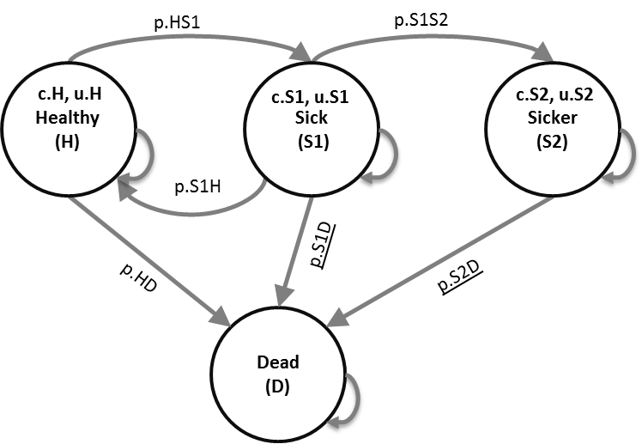

**Results**

1. Target and model explortation:
   * 3 calibration targets

Survival Prevalence

 

Prevalence of S1 within those who are ill



* + Check that model works



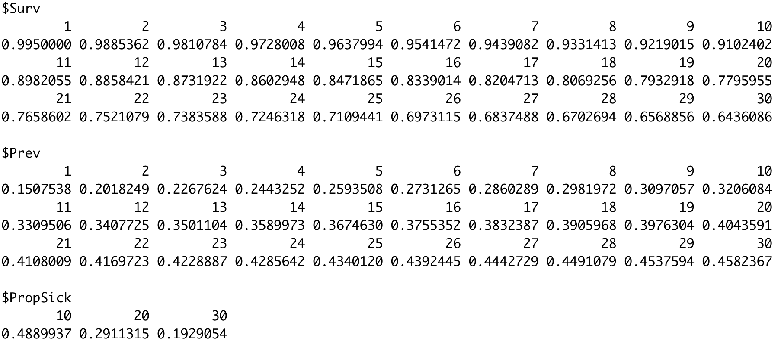

1. Random-search calibration with 1,000 samples ( using set.seed(072218) ):

Top 10 best-fitting input sets



Top 100 best-fitting inputs sets

* + scatterplot3d() pairs.panels()

 

* + Best parameter set compared to calibration targets

Surv Prev

 

PropSick



1. Nelder-Mead calibration with 100 initializations ( using set.seed(072218) ):

Top 10 “best-fitting” input sets (note the similarity – why?)



* + scatterplot3d() pairs.panels()

 

* + Best parameter set compared to calibration targets

Surv Prev

 

PropSick



1. IMIS Bayesian calibration ( using set.seed(072218) )

1000 random samples

* + scatterplot3d() pairs.panels()

 

* + MAP estimate compared to calibration targets

Surv Prev

 

PropSick



Comparison of calibration methods

|  |  |  |  |
| --- | --- | --- | --- |
|  | Best parameter set for |  |  |
| Parameter | Random search | Nelder-Mead | IMIS |
| p_S1S2 | 0.06924419 | 0.07518499 | 0.07569803 |
| hr_S1 | 4.24820836 | 3.90523231 | 3.83598088 |
| hr_S2 | 10.78066841 | 11.64815122 | 11.82035667 |
| Overall fit | 173.98182686 | 175.48804987 | 175.4765 |